**CS5542 Big Data Apps and Analytics**

**LAB ASSIGNMENT #1**

**Lab Submission through the following link before 2016/1/27 (W) 11:59PM.**

**http://goo.gl/forms/Uc7gbpGZDs**

1. Write a map-reduce pseudo code for Sum of Two Matrices.

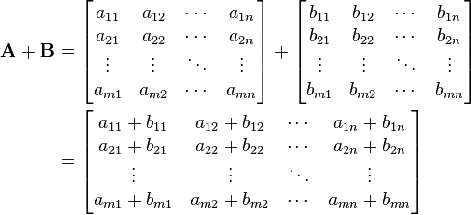

1. **Create GitHub Account**. Create a repository in remote Github. Clone it to local machine.

Create 2 (Source and Documentation) directories in local github.

Put the document with the pseudo code of question (1) under documentation directory in the local windows Github and sync it to remote Github.

1. **Create ZenHub Tool Account**. Create a board, 3 iterations, at least 5 tasks and show the analytics graph.